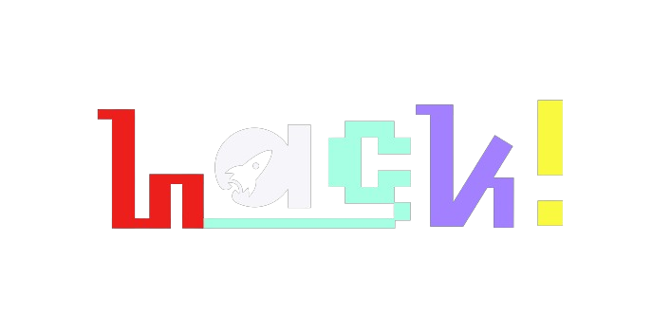

***HackINSAN 2024***

***Project Report***

Dev X | Memo Agility

Melvin Cheah Hong Lek (23)

Ng Kah Weng (21)

Yusuf Fawwaz bin Fadhlullah (15)

Uthman Wazir bin Mohamad Azlan (15)

## **Source of Inspiration**

## By relating insurance with things Gen Z enjoys to do. Gamification and incentives concept that promotes engagement and stickiness. Promoting a healthy lifestyle by rewarding healthy habit.

## **Project Overview**

## The solution involves insurance companies collaborating with smart wearables and fitness tracker applications. Then, the insurance companies can acquire the user (including Gen Z) data to provide a personalized health insurance plan for them. The health insurance plan can be presented as an additional feature in the applications. This can expose the Gen Z user to health insurance. The website can include a straightforward explanation of the health insurance plan for Gen Z to better understand them, preferably in video format.

## If the user subscribed to the insurance, engagement can be boosted by providing incentives to the user in the sense of reward points. The points can be used to exchange for discounts on the premium of the health insurance bought. Additionally, reward points can be earned through various healthy activities tracked by the wearables, such as reaching daily step goals, maintaining consistent exercise routines, or achieving optimal sleep patterns.

## **Development Process**

## Research about the insurance industry.

## Market Research is done to understand Gen Z’s needs and preferences regarding health insurance.

## Develop detailed user stories and use cases to guide development

## Evaluate the technical feasibility and potential partnerships with wearable and fitness tracker companies.

## Figma is used to design the interface sample.

## **Challenges Encountered**

Finding the right platform to reach Gen Z. It’s very broad and a lot of approaches are not feasible. Figuring out how to provide discounts to the user. Figuring the demand of the current market through market research. Idealization process, multiple prototypes had been scraped and rebuilt causing lot of stress and disappointment to the team.

The challenges are overcome with excellent guidance from fellow mentors who are there to provide assistance and valuable insights whenever we need it.

## **Key Learnings**

## Acquired insurance knowledge and the current situation of the insurance ecosystem. Learned about the requirements of Gen Z. Learnt about the concept of providing a new experience to customers.

## Be brave, scrap the entire idea that has been worked for hours. Do not hold on to an idea that is wrong because of self-esteem. Adapt, improvise and evolve from small problems of existing products. Try our best to overcome problems posted by the real world.

## Understanding the real-world application of the software. How does the software development cycle work? How does the demand from customers work?

## Understand the industry of fintech and insurtech.

## **Future Directions for Project**

Continue integrating more insurance companies.

Expansion of Partnerships. Additional Wearable Integrations: Expand partnerships to include a broader range of wearable device manufacturers and fitness app providers to ensure compatibility with the most popular devices used by Gen Z.

Advanced Personalization: with Ai and machine learning. Using Ai and machine learning to r personalise health insurance plans based on more nuanced data analysis.